To set up security questions follow the steps below:
Step 1: Go to http://outlook.com/gptc.edu.
Step 2: Input your username and password.
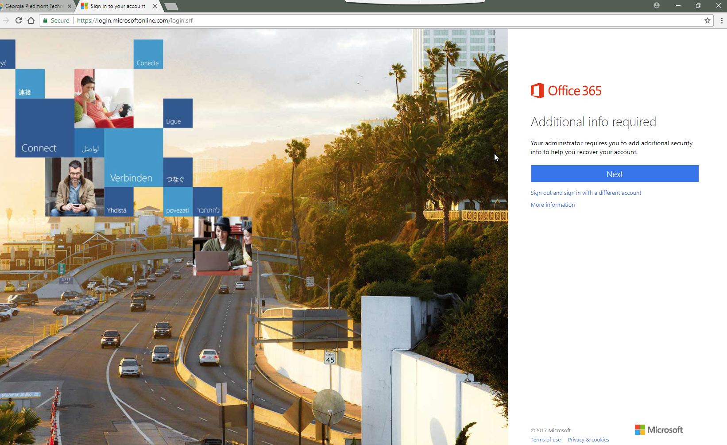
Step 3: You will now be on the screen to set up security questions as well as a backup email and phone number. Complete all of these steps so you never lose access to your account.
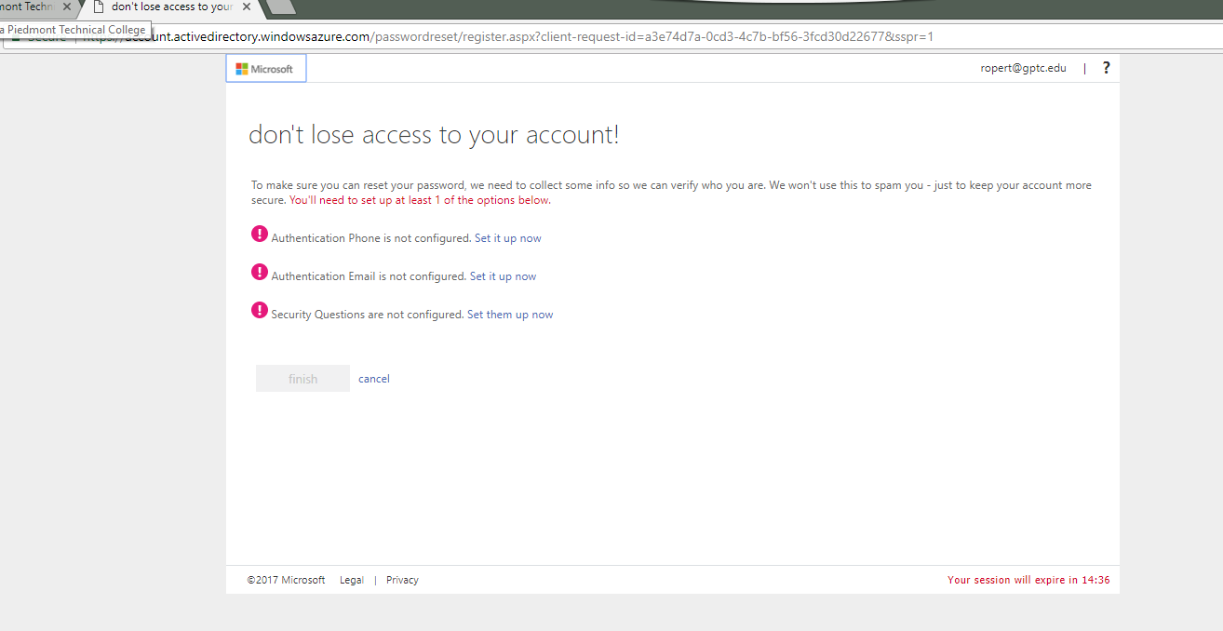
Step 4: Select the first option of “Set it up now” to set up your phone number. This should be a number you always have access to that can receive calls as well as text messages. Once you have selected your area code (country) and entered a phone number select the “text me” or “call me” option to authenticate this number. This will finish the set up of your phone number. If you ever need to use the “Forgot Password” option, you can now select this method to receive a verification code to access your GPTC email. 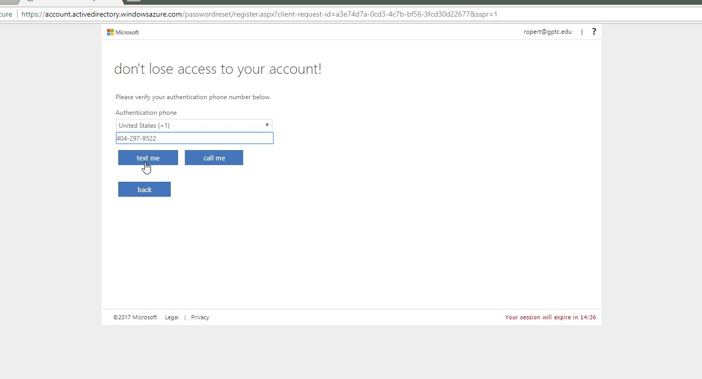
Step 5: Select the second option of “Set it up now” to set up a personal email account as a verification method. This should be an email account you always have access to. Once you have entered an email (Note: this cannot be your GPTC email) select the email me to send a verification code to this email account.
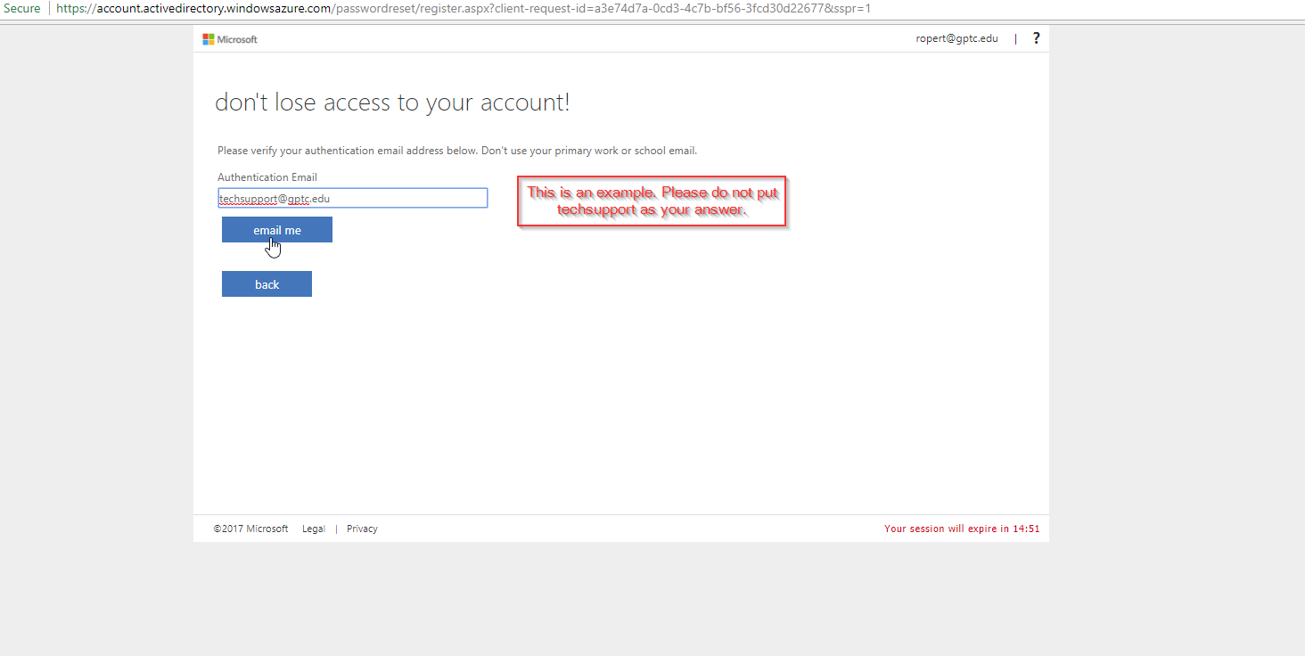
Step 6: This step is critical to have access your email. Please select 5 security question that you can remember the answers to and input those answers. Once you have entered all 5 and are confident with your answer, select save answers.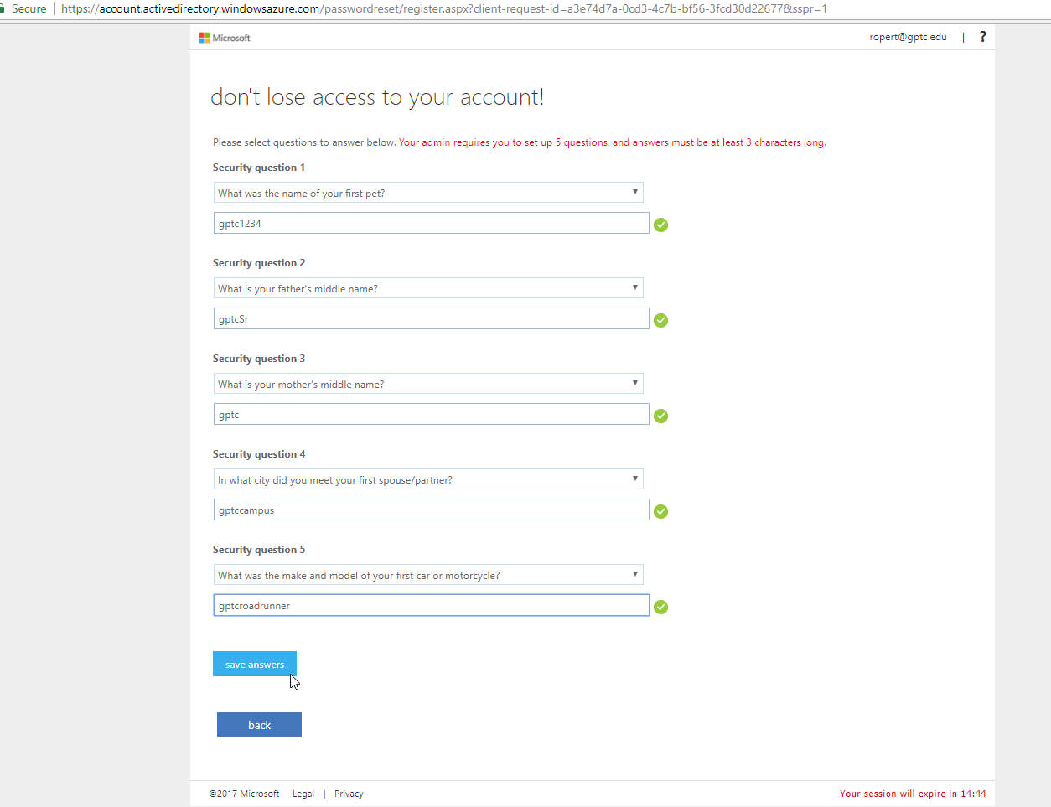
Step 7: You should now have green check marks next to each authentication method. You can now select finish and you will be logged in to your GPTC email account. (Note: In this example there is only 1 check mark. This is just an example to show you what to look for in case you forget to enter an authentication method).
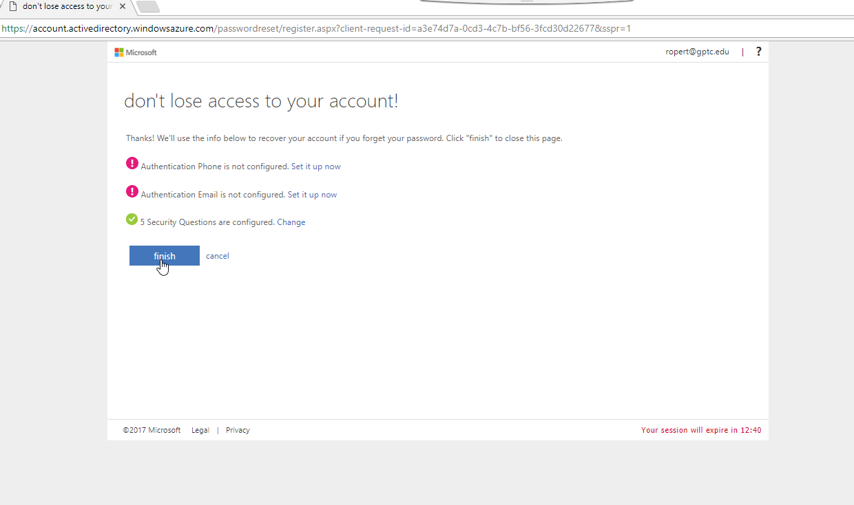

Extra information below:
If you have never logged into your GPTC account via web browser, you might see the screen below. If you do see this screen. Select your language and time zone. (Note: A second screenshot has been provided for this example to show you where Eastern Time Zone is located on the time zone list).
